|  | GROUP MEMBERS:  Allan Villanueva, Duhuang Licai, Ryan Marples, Ryan Salom, Tyler Saechao, Ali Rajeh  MKTG 310 - Marketing Research  May 9, 2019 |
| --- | --- |

**Letter of Authorization**

3500 Deer Creek Road Palo Alto, CA 94304 USA

Date: 4/11/19

25800 Carlos Bee Blvd, Hayward, CA 94542

Please note that Dr. Judy Ma’s CSU East Bay marketing students, have the permission of the Tesla Inc. to conduct marketing research for their study, “MKTG 310 - Marketing Research Tesla Case Study”

Students will contact an online survey using Survey Monkey in an attempt to identify customers wants and needs when it comes to electric automobiles. The online research activities will be finished by _____*(5/9/19)*___.

The students have agreed not to enter any of our buildings or restrooms or interfere with the flow of pedestrians or vehicles. Employees will not be allowed time from their work duties to complete the surveys. The students have also agreed to provide to my office a copy of the Case Studies stamped consent document before they recruit participants on campus, and will also provide a copy of any aggregate results.

If there are any questions, please contact my office.

Signed,



Elon Musk, CEO

**Letter of Transmittal**

Allan Villanueva, Duhuang Licai, Ryan Marples, Ryan Salom, Tyler Saechao & Ali Rajeh

California State University, East Bay

25800 Carlos Bee Boulevard

Hayward, CA. VBT 222

May 6, 2019

Dr. Judy Ma

Professor, Marketing & Entrepreneurship

California State University, East Bay

25800 Carlos Bee Boulevard

Hayward, CA. VBT 352

Dear Dr. Judy

With your letter of authorization, dated April 11, 2019, you authorized us to conduct a research project for Tesla. With this letter, I am hereby transmitting to you the report of that project, entitled “Tesla Marketing Research.”

The method used to generate the findings of this report is described in detail in the report. Moreover, the method follows that described in our proposal to you. We believe the report accomplishes the research objectives we set out at the beginning of this process and, therefore, you should be able to use the information contained herein to make the important decisions needed for this project.

My colleagues and I have been pleased to work with you on this project. We are prepared to make a presentation of the report at your convenience. Do not hesitate to call me at (510) 111-2345 should you have any questions.

Sincerely,

Allan Villanueva, Duhuang Licai, Ryan Marples, Ryan Salom, Tyler Saechao, & Ali Rajeh

**Table of Content Page**

1. Letter of Authorization…………………………………………………………………..1
2. Letter of Transmittal ……………………………………………………………...…......2
3. Table of Content……………………………………………………………………..…..3
4. Abstract……………………………………………………………………………...…..4
5. Introduction………………………………………………………………………..…….5
   1. Organization Information………………………………………..………….........5
   2. Research Problem and Objectives…………………………………….…….…....5
6. Method…………………………………………………………………….………….…..5
   1. Data Collection………………..…………………………………………….........6
   2. Fieldwork Experience and Challenges while Collecting Data ……………...…...6
7. Results……………………………………………………………….……………..…...6-7
   1. Limitations………………………………………………………………..……...7
   2. Conclusions……………………………………………………………….…….7-9
   3. Recommendations………………………………………………………….....9-10
8. End Matter……………………………………………………………….……….…..10-14
   1. Reference list……………………………...…………………….……….….…..11
   2. Endnotes (copy of survey)………..…………….……………….……....…..…..12
   3. Data Results (graphs)…………….………...…………....……...……..….…..13-17

**Abstract/Executive Summary**

Tesla is a car manufacturing company that is known for producing an all electric car. At first, these cars could only be afforded by the high class luxury car driver. The prices were so high and the production was so limited that they were considered exclusive cars. In recent years, they have started to produce a more affordable option for some but not for all. We have set out to find out what the view of the general public is of the manufacturer, Tesla. The way we have done our research was by sending out surveys that probe to find out what our audience thinks of Tesla and what they could do better as a whole. Many of our respondents are within the age range of 19-32 years of age. Our research shows that our audience responded to our surveys and informed us that most make less than enough to afford the least expensive model of Tesla. Our audience also has showed us that they think a brand new car should not cost more than $32,000. We have found that the participants in our surveys have more interest in Tesla as a car producer, than other companies such as Ford. Participants have showed that they are still willing to buy a car even if they know they would have to wait for their purchase to be made. The same participants who claimed that they would wait for their purchase to be made also claim that they would feel safe with one of the key features of a Tesla car, which is the autopilot feature despite claims that there have been accidents due to the autopilot feature. The results from the surveys show that most of our participants are not sure whether they are purchasing a new vehicle within the next year or so. With all of the research results, there were some problems that presented themselves that were not taken into account. Problems such as finding out what everyone's perception is of the company right off the bat, as well as having data that is only specific to participants within the bay area, and not outside of those limits. Having participants outside of the bay area in its own could have altered our results significantly. Some recommendations that we have to present are to potentially produce a cheaper option for more customers to afford. The more customers is aiming for the Generation Z crowd, which is the age range of 18 - 24 years old. Another recommendation is to continue to focus on energy efficient products, while doing this Tesla should try to also keep a positive brand image to the general public at all times.

**Introduction**

**Organization Information**

Tesla, Inc. is an American automotive and energy company founded in 2003 and currently based in Palo Alto California. Tesla is dedicated to being the industry leader in totally electrical automotive technology and energy storage products (lithium-ion batteries). The automotive segment includes; design, development, manufacturing, and sales of electric vehicles. Although they boasted a large revenue stream of $4.54 billion in 2019 by delivering roughly 63,000 cars, the company consistently reports negative profits due to large investments in research and development and aggressive expansions in production to meet the growing demand of electric vehicles.

**Research Problem and Objectives**

Tesla does not know what appeal to the younger generation. What can Tesla do to distinguish their electric automobiles from the competition and capture as much of this emerging market as possible?

1. How can Tesla appeal to the younger generation?
2. What can Tesla do to encourage purchases of automobiles now and in the future?
3. How can Tesla remain a key player in the market?
4. How is the safety of Tesla’s autopilot perceived?
5. Is the production rate for Teslas affecting consumer’s decision to purchase?
6. Will a larger variety of vehicles encourage sales?

Our research will attempt to identify customer preference and expectations as they relate to age, sex, income, driving habits, and previous automobile purchases.

**Research Problem**

Tesla attracts the younger generation by media, vehicle design, and features; although, Tesla vehicles attracts older buyers. The results for our survey had substantial amount of younger crowd, which had results of affording a Tesla. Even though, Tesla came out with the model 3 to attract millennials and be affordable, but millennials aren’t appeal to Tesla because it implies wealth. One of the main reasons it attracts the younger generation is Tesla vision and how it goes beyond the traditional vehicles. Tesla faced many challenges and problem last year including concerns over ability to build cars at scale, finances, and public comments; although, they have high amount of customer satisfaction. The company still dealt with inconstance production rate. The automaker is known for producing luxury electric vehicles, which mostly appeal to high income consumers; however, the model 3 was meant to be more accessible millennials with the start price of 35,000. Our survey had high amount of responses that a brand-new car should cost around 25,000-30,000; therefore, the model 3 main goal to get consumer to purchase an affordable luxury electric vehicle. Although, Tesla main problem is the model 3 production rate the company ended up producing over 20,000 model 3 vehicles per month by end of the year in 2017, but only delivered 1500 model 3 vehicles during the fourth quarter. Tesla production rate hits a curve when they expected their growth to have high demand when launch by aiming to increase its production rate to 5,000 vehicles per week by the end of the second quarter.

Tesla can remain a key player in automobile market by not being in the traditional automobile business with a highly performance electric vehicles. With Tesla establishing their present by having a niche product it allowed company to create a strong brand and different approach purchase decision. Therefore, by Tesla having a strong brand it can support strategic expansion in the global market, it creates strength for the business as a competitive player in the automotive industry. In our vehicle survey majority of the responses were positive; more than half of our responses would wait for the vehicle to be made. Therefore, by having a strong brand Tesla took a different approach by selling direct to consumer, but for Tesla to remain key player in the market they need increase market share. Tesla has limited market present and supply chain; even though, most of their revenue is generated in the United States the company manufacture is based in the US. Tesla needs to reform its strategies to increase their supply chain for growth and global expansion. For Tesla to encourage vehicles sales they need significant economic growth with global expansion; therefore, they’re relying on their supply chain to increase expansion with production and sales operations. Also, with Tesla expanding to Asia it can increase its revenue stream and expand renewable energy market. This can be a huge opportunity for Tesla by establishing its market place. The vehicle survey had a reliable response that understanding what automobiles will be around in 30 years and how electric vehicle would benefit in the long run.

**Method**

The method we chose to approach and use in this marketing research was exploratory and descriptive marketing research. The reason being is because while we did know that Tesla had a problem within the company (due to the reflection with how their market shares were doing), we did not know what exactly the problem was. So, in order to fully understand and find the specific problem(s), we had to conduct a questionnaire with the general public to see if any problems arise through brand perception. Our targeted market were people who currently drive and have some sort of vehicle in their possession. Within exploratory research, we were able to use secondary data analysis and a lead-user survey to find the problem that Tesla had. With secondary analysis, we knew that Tesla had a problem, however, the problem may have been derived from a past incident or so. Off the bat, we assumed that Tesla’s technological advances was a factor regarding how the company’s performance was on the general public. After being able to interpret what we thought was the true issue with Tesla, we conducted a lead-user survey which the purpose was to see what user’s first thoughts on Tesla’s technological advances, i.e. auto pilot, if it applied to them. These users also known as, early adopters, were part of our target and seeing how they reacted to these advances and with that, we derived even more issues within the company.

Another approach we took was descriptive research, which was to use the data gathered from our sample size to represent the larger fraction of the population in regards of the general thought and concerns of Tesla. One crucial study we conducted was cross-sectional studies. While the survey revolved around people’s interpretation of Tesla, we used a moment in time as a measurement which was gas prices in USD. Our survey asked participants specific questions regarding fuel at this specific moment as it captures how much fuel per gallon was. We also used a form of continuous and discontinuous panels, which was the same set of questions in a specific order regarding vehicles and, ultimately Tesla and its features that may represent a community as a whole. Some studies that we included within continuous panels was how consumers were able to include certain factors that would cause them to either switch or stick with brands regarding those factors.

**Data Collection**

In order to come up with a reasonable hypothesis, we conducted a questionnaire that revolved with warm-up questions, nominal questions, ordinal, and much more. These types questions would provide us with a hypothesis that could help us point toward how consumers feel about vehicles and future technological advances. We started the questionnaire with questions to start off with age, gender, and if they had a valid driver’s license. Which leads to how many vehicles said individual own and if they plan to purchase one in the near future. We also found out that at least half of our participants do not pay for their car monthly, which could mean that they have a pre-owned or purchased a pre-owned vehicle and do not have to make monthly payments of any sort. To get a glimpse of what kind of participants we had, we asked for their annual income and a general idea for how much they think a new car should cost. Accounting not only for the cost of the vehicle, we asked participants how often they pumped gas for their vehicle and how much it averages out per month. To conclude the type of information we gathered from our participants it included how many miles on average they drive in a year, ranking the top five vehicles as of 2018, if they found themselves to be environmentally conscious, what types of cars they believe will be around in the near future, and how heavily they factor in car variables such as: price, appearance, and function.

**Fieldwork Experience and Challenges while Collecting Data**

Our fieldwork experience was overall a good learning experience, however, there were some hurdles while conducting our market research. One of the first hurdles was that, while we knew Tesla had a continuing downward trend of market shares, we didn’t know exactly what the problem was, therefore we did not know what type of research we needed to conduct to help us find out. Also getting the questionnaire out there for participants to complete was also a difficult thing to do, especially since people are generally skeptical about research questionnaires/surveys. Other than the physical portion of the questionnaire and figuring out how to pinpoint a problem, coming up with questions to help narrow down that was fairly simple and definitely helped with the input of the participants.

**Results**

The data we collected provides answers to many our original research objective questions. How can Tesla remain a key player, appeal to the younger generation, and promote the purchase of electric automobiles now and in the future? The data clearly shows survey participants are more interested in performance then price or appearance of electric automobiles. 67% of participants would be willing to buy a car before it has gone into production, and 62% would feel safe using new autopilot technology. Potential customers in our survey believe a new car should cost somewhere between $20,000 and $31,000. More often than not, survey respondents do believe driving an electric vehicle will benefit them in the long run. Only 9 out of 104 respondents did not believe this to be true. When asked to rank brand preference Toyota came in first and Ford finished in a distant last. 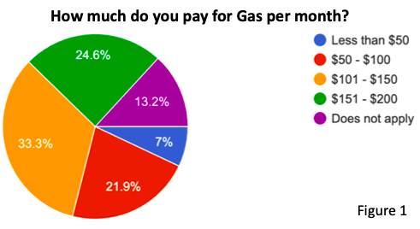

As for the demographics of our survey participants; only 9% are older than 28, 67% are Male, 85% make less than $20,000 a year, and 88% of those surveyed own one car or less. Figure 1 displays monthly gas expenses reported and only 29% believe there will still be gas powered vehicles on the road in 30 years. 5.5% currently lease their vehicles and 16% plan on purchasing a new car.

Those that filled out the survey consider themselves aware of global warming, eco friendly, and believe they would be making a difference in the world by driving an electric vehicle. Even more than benefiting the planet, 80% of people agree purchasing an electronic vehicle will benefit themselves in the long run.

**Limitations** With the constraint of time working against us, we were not able to collect the desired sample size to suggest concrete information to act on. Because 114 responses is sufficient, we are still confident in this presented report and its findings. Along with the constraint of time, the lack of attention to our survey limited our findings. Although our survey covered the six objectives we set out to cover, some are very brief and lack depth. Our findings suggest concrete courses of action to take, only being based off of a couple of findings. We hold ourselves to higher standards, failing in this aspect. We hope that we can present our findings with full confidence in the future.

**Conclusions** Before we present our conclusions, we want to preface the importance of the inevitable shift in consumer behavior worldwide. With the ongoing debate on the severity of climate change, with many countries enforcing strict environmental laws, there will be an increase in demand for clean energy alternatives. Because Tesla’s products align with current and future environmental trends, your company will eventually attract customers from this shift in consumer behavior.  
 We ran a correlations test to determine which questions in our survey are associated with one another. The strength of association between any two variables can be measured on a scale, ranging from a very weak association to very strong. The strength of association is determined by a coefficient range presented by our findings. From our tests, we found that a user’s belief that driving an electric car will ultimately benefit them in the future and electric cars benefiting the world has a strong correlation. Correlations pertaining to a user’s belief that driving an electric car will ultimately benefit them in the long run included their familiarity with climate change and their eco-friendliness, both being moderate correlations. We also found that a car’s performance ranking is moderately correlated to eco-friendliness.

With all of this in mind, we come to the same conclusion, both statistically and logically, that consumer behavior will inevitably shift towards electric vehicles. Because users found it both useful to themselves and the planet, they will have a higher propensity to purchase an electric vehicle, especially with the inevitable environmental laws being enforced. This information will factor into both this conclusions section and the recommendations section following immediately after this. Because 90.3% of those surveyed were under the age of 28, most of the responses were filled out by the younger generation. This demographic will give insight on the preferences of future consumers for Tesla products. In our survey, we asked respondents to rank the importance of the performance of a car, the price of a car, and the looks of a car on a scale from 1-5.Based on the information gathered from our research, Tesla can appeal to the younger generation by prioritizing their cars’ performance, price, then looks in that order. Out of the three, the performance of a vehicle ranked the highest at 455 points, followed by price at 400, and finally looks at 384. These components were run under an analysis of variance (ANOVA) to ensure that these factors are independent of each other and purposefully yield different means. Because all values of significance were under .05, there is a significant difference between these factors, ensuring that performance is the most sought after factor of the three choices. By focusing on the performance of their future vehicles, Tesla can work to further distinguish themselves from their competitors.  
 Tesla can work to encourage purchases of automobile now and in the future by mirroring established brands. While performing our analysis, we worked to isolate a dependant variable, the surveyor's desire to purchase a vehicle within a year, to find basic relationships within our survey to suggest the respondent's decision. We found that whether they’d wait for their vehicle to be made/delivered, the high rankings of Honda and Toyota, and their current monthly car payments are factors of a basic relationship in regards to the surveyor’s decision to purchase a vehicle within the year. Because Honda and Toyota are both well established brands, respondents seem to drift towards a strong brand presence. The details as to why consumers favored these brands, as opposed to Ford, Hyundai and Tesla, was not touched upon in this survey, but it may be indicative of the monthly payment of those that took the survey.   
 Tesla can remain a key player in the market by focusing marketing efforts on those that are able and willing to purchase a Tesla. Of those surveyed, 85% made less than $20,000 a year. The younger generation should not be the prime focus with the lowest purchase price of a Model 3 being $39,500. Because it would cost $399/mo to lease a base Model 3, with only 23.7% of surveyors willing or able to spend more than $300 on their monthly car payment, it is in Tesla’s best interest to focus on prime candidates to purchase their vehicles. By focusing on those that are willing and able to purchase your vehicles, Tesla will be able to remain a key player in the market.   
 From our survey, 61.7% of responses stated that they would feel safe using any type of auto pilot feature. With the recent misconception of Tesla’s autopilot feature, it is indicative in our findings that only 38.3% of people would not trust any type of auto pilot feature. Without prior statistics to show any sort of change, we cannot suggest that the public’s perception of Tesla’s semi-autonomous autopilot system changed.   
 The production rate for Model 3’s was in full force during 2018. In our survey, we asked respondents if they would buy a car if they had to wait for it to be made. With 67.3% suggesting they would, we decided to dive deeper into the subject. We made a cross tabulation in an attempt to compare the respondents’ decision to purchase a car within a year to whether they’d purchase a vehicle if they had to wait for it to be made. With 68.10% of people saying they did not plan on purchasing a vehicle but would purchase a vehicle that still had to be made, while 60% of people that do not plan on purchasing a vehicle also saying they would not wait for a car to be made, it is indicative that our respondents do not care that they have to wait to receive their car. Although this test came back with a significance level over .05 (.069), it was our best bet at explaining why this objective should not be an issue for Tesla.   
 Referring back to our results that suggested a relationship between respondents plan to purchase a vehicle this year and the high rankings of Honda and Toyota, it is suggestive that both Honda and Toyota have a grasp on success. Given their wide variety of vehicles, they are able to reach a wide variety of consumers in part of their low and affordable price. In our survey, we asked participants to suggest how much a brand new car should cost. Valid answers ranged from $15,000 all the way to $35,000. Toyota offers their 2019 Yaris starting at $15,000, while Honda offers their Fit at $16,000. Both Honda and Toyota offer expansive variations to their models, reaching a large part of the lower-end market. Not only do they offer low-pricing cars, they also offer luxury and higher-end models. Although there is no concrete evidence suggesting a wider variety of vehicles encouraging sales, offering a wider range of products that touch open a wider price point should be considered.

**Recommendations**

In order for Tesla to appeal to the younger generation, ensuring the companies longevity should be a top priority. Due to the economic state of the younger generation, it’s difficult to weed out those willing and able to purchase a Tesla right now. Focusing on the younger generation in the coming decades will prove efficient, especially with the global climate crisis we are experiencing right now. By focusing on the performance, price, then looks of future models and their variations, you can hope to distinguish yourselves from the competition.  
 Tesla can encourage purchases of automobiles right now by focusing on the right target market, ensuring they remain a key player in the market. With 56.2% of those surveyed making less than $20,000, Tesla can not waste any efforts in appealing to the younger generation as of now. Although 55.56% of the people between the ages of 19 and 23 stated that they plan on purchasing a vehicle within the next year, their Model 3 is not an affordable option for them. With the North American market for Model 3’s reaching its saturation point, Tesla should focus on other developed markets that are beginning to enforce stricter environmental laws, China and Europe both being prime candidates.   
 In the future Tesla should consider offering an even cheaper variant of their vehicles in order to grasp a wider part of the market. Although it is too early for electric vehicle manufacturers to consider the availability of variants to their cars due to the lack of technology, the youth of the industry, and the high manufacturing costs, it is essential to consider taking any opportunity to take advantage of this option in the near future. Providing a well performing electric vehicle at a low price point would shake the market.

**Reference List**

Kumar, Rahul “Electric Vehicle Market by Type (Battery Electric Vehicle, Hybrid Electric

Vehicle, and Plug-in Hybrid Electric Vehicle), and Vehicle Type (Passenger Car, Commercial Vehicle, and Two-Wheeler) - Global Opportunity Analysis and Industry Forecast, 2018-2025” *Allied Market Research*, January 2019, <https://www.alliedmarketresearch.com/electric-vehicle-market>

O’kan, Sean “Tesla is selling fewer cars, but says it has ‘sufficient’ cash, The Model 3’s

wild growth finally cools off” *The Verge*, Apr 3, 2019, <https://www.theverge.com/2019/4/3/18291922/tesla-sales-decline-q1-2019-deliveries-production>

Schreiber, A. Barbara & Gregersen, Eric “Tesla, Inc. AMERICAN COMPANY”

*Encyclopedia Britannico, Apr. 4, 2019,* [*https://www.britannica.com/topic/Tesla-Motors*](https://www.britannica.com/topic/Tesla-Motors)

[Baer, Drake “The Making Of Tesla: Invention, Betrayal, And The Birth Of The Roadster”](https://www.businessinsider.com/author/drake-baer)

*Business Insider,* Nov. 11, 2014,[*https://www.businessinsider.com/tesla-the-origin-story-2014-10*](https://www.businessinsider.com/tesla-the-origin-story-2014-10)

[Ayre, James](https://cleantechnica.com/author/nathan/) “What Are Elon Musk’s Ultimate Goals? Overview Of Tesla & SpaceX Plans”

*Cleantechnica,* February 17th, 2018,

<https://cleantechnica.com/2018/02/17/whats-elon-musks-ultimate-goal-overview-tesla-spacex-plans/>

**Endnotes**

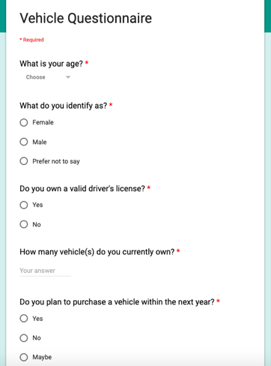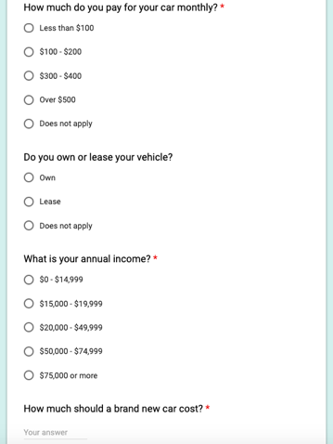

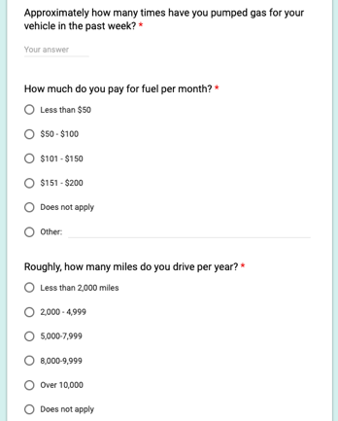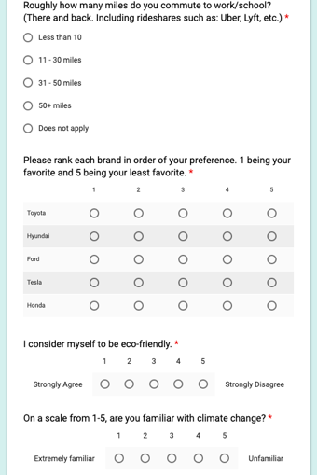

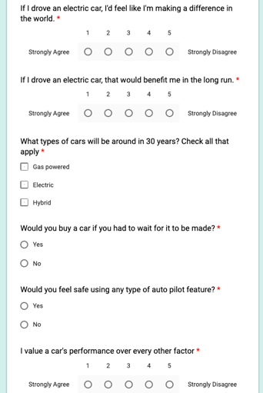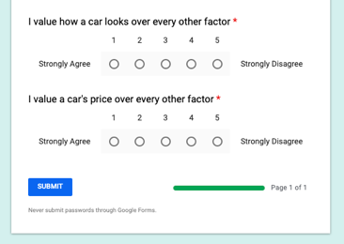

**Data Results**

  
